**Request from Stromma Customer Support**

1)The title: "Stromma Customer Support / Stromma Customer Support" can be queued in one line, as it was originally. Unless it affects the size of the window so that it becomes too big again?

2)The Phrase " Welcome! How can I help " there can be two lines, so it looks better. it's: "welcome!"on their own line and the rest on their own line. The font is also much larger than elsewhere, meaning it can be slightly smaller.

3)"Were you happy with the help?"at first, he suggests to the disgruntled. Is it possible to change it so that it is initially assumed that the customer has received a good service, i.e. green first.

4)When you get a response from" us " in a chat, the user becomes quite loud. Can you take it off?

5)When you enter text in backoffice, you read the name of the respondent to the user. Can you read anything else, for example Stromma's customer support messages etc.?

6)The "settings" logo now appeared in the chat window where you could send an email. It can be removed.

**Taika Stromma Chat button at the web page**

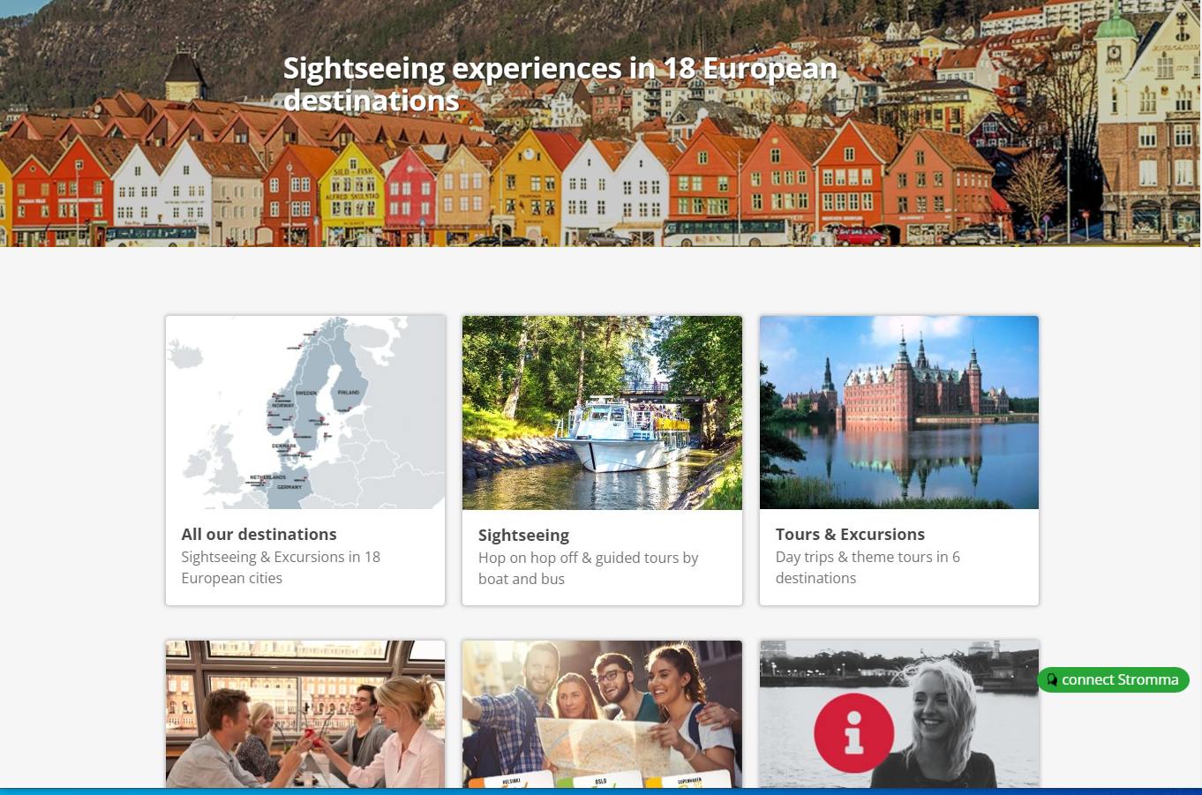

**Taika Stromma Chat is openat the web page**

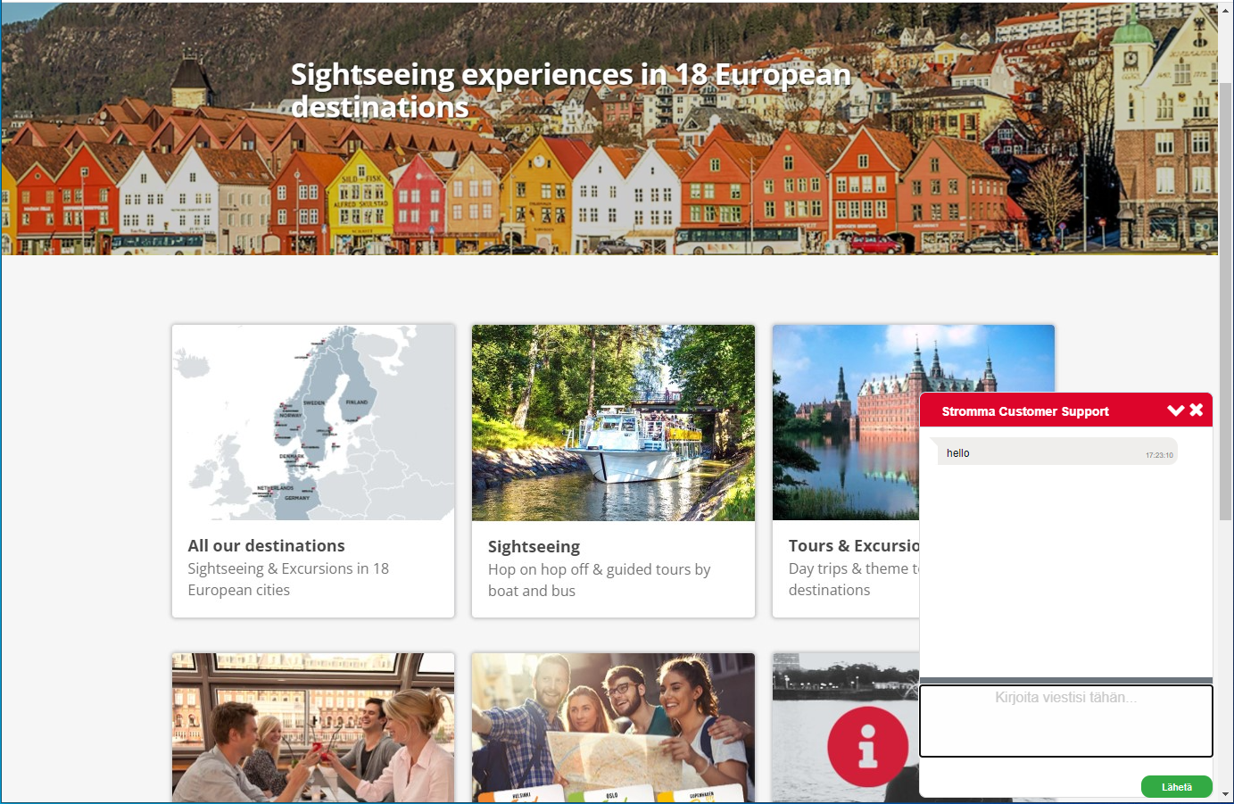

**Chat window**

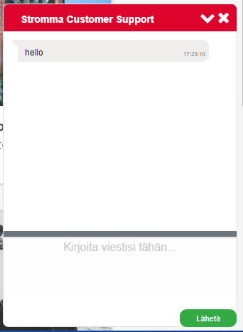

**Description of the changes made in the previous version chat**

The changes in the previous chat were made for satisfying the client's desire (6 requirements are given above) and for improving the convenience of using the chat.

**\*\* Needs to add several translations on the server**

**- good**

**- bad**

**- Customer support writing**

**- Customer support online**

**-Yes**

**-No**

**-** **Do you want to end the conversation?**

**Next changes were made at the chat**

1. The name "Stromma Customer Support" is displayed in one line.

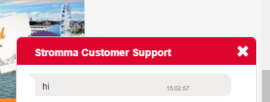

2) The width of the chat window has been increased to 330 px (it was 280 px)

3) The background color of the header is red DD052B (in accordance with Stromma site) and the button color is green (27F536) in accordance with Stromma site

   

4) The welcome phrase "Welcome! How can I help " is output in two lines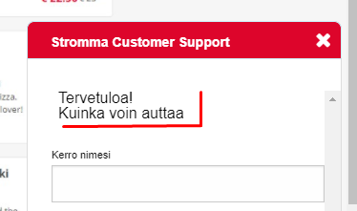

. In order to display a greeting in two lines, you need to write it in the chat settings window in two lines. The front-size font-family is configured in the taika-chat -preview.css file

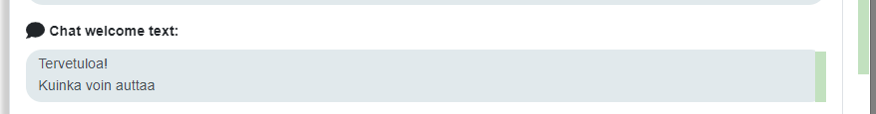

5) In the chat, the name**-- Customer Support online --**appears on the side of the tablet when the agent connects to the chat,( depends from language settings)

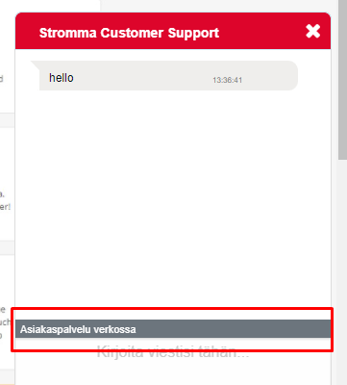

6) In the chat, the name**-- Customer Support writing--** appears on the side of the ticket when the agent's response is printed ,

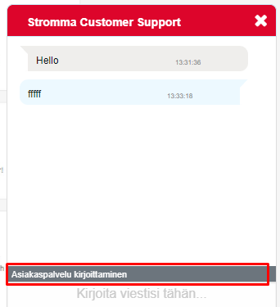

7) If there is no mark in the Sound notification checkbox, the sound on the client side is not played when a message is received from the agent.

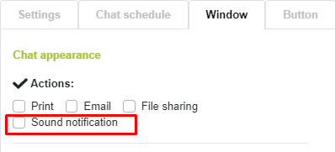

8) In the chat widget on the client, the widget settings option has been removed (the gear icon has been removed). The absence of this option only To use the chat for another client, the option to configure the should be returned.

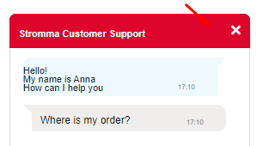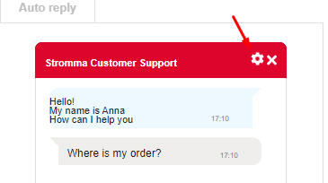

9) In the Service quality assessment window, the evaluation order has been reversed. Now there are Estimates in descending order (-5-4-3-2-1)

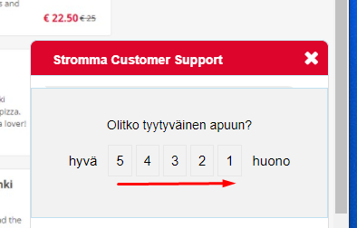

10) In the quality of service assessment window, the words good---bad have a translation depending on the setting language

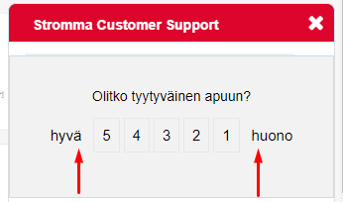

12) In Chat settings the window - “Box where you can copy the script which you use in your own site:” was increased .

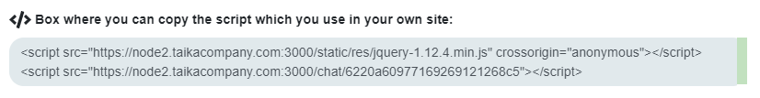

13)The button  was added

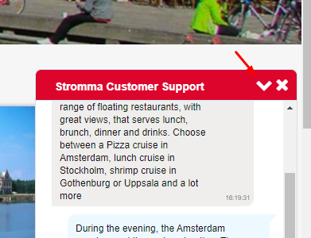

When you click on the button, the window disappears (but the chat session does not close, the task is still open)

14)The button ‘close’ 

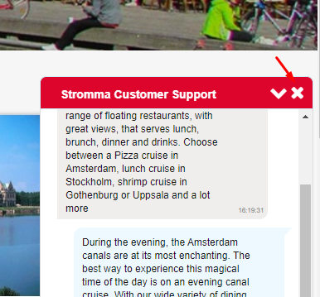

When you click on the button  the confirmation dialog is open

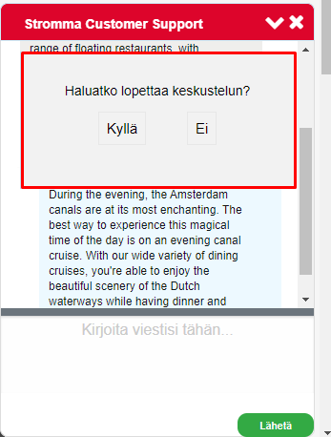

If click on the button **“NO”** then the dialogs will be closed and client could communicate with agent further

If click on the button **“YES”** the dialog window was changed to windows “Estimation dialog”

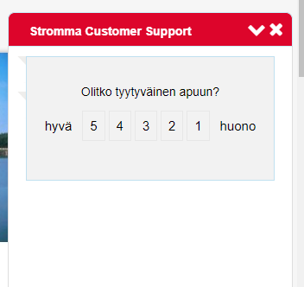

When the client chose the mark then the windows “Estimation dialog” will close and the task will close( with estimation

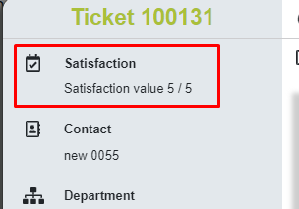

When the client again pushes the chat button “connect” on the same browser page

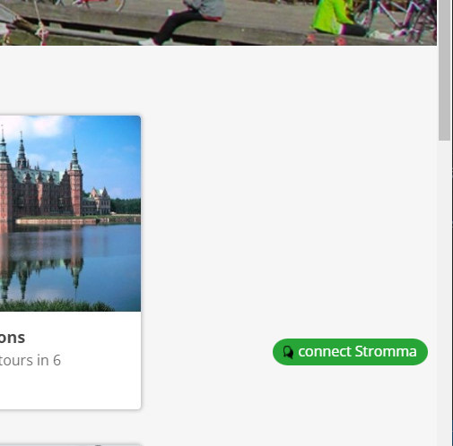

**Then the chat will open without asking the name**

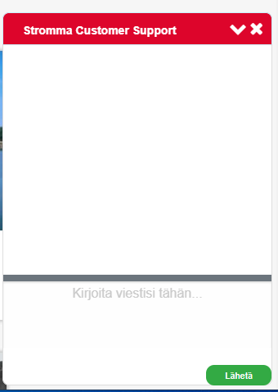

and **new task( with new id) will be created on agent side**

